South Sudan

## Respect for rule of law (ROL) data

The data set shows the data on the respect of the rule of law for the country.

## # A tibble: 19 x 5  
## country iso3c date ruleOfLaw ruleOfLawCategory4   
## <chr> <chr> <dbl> <dbl> <chr>   
## 1 South Sudan SSD 1996 0.809 ROL moderately respected   
## 2 South Sudan SSD 1998 0.909 ROL moderately respected   
## 3 South Sudan SSD 2000 0.862 ROL moderately respected   
## 4 South Sudan SSD 2002 0.859 ROL moderately respected   
## 5 South Sudan SSD 2003 0.862 ROL moderately respected   
## 6 South Sudan SSD 2004 0.840 ROL moderately respected   
## 7 South Sudan SSD 2005 0.840 ROL moderately respected   
## 8 South Sudan SSD 2006 0.995 ROL moderately respected   
## 9 South Sudan SSD 2007 0.911 ROL moderately respected   
## 10 South Sudan SSD 2008 0.911 ROL moderately respected   
## 11 South Sudan SSD 2009 0.911 ROL moderately respected   
## 12 South Sudan SSD 2010 -0.880 ROL moderately disrespected  
## 13 South Sudan SSD 2011 -1.38 ROL highly disrespected   
## 14 South Sudan SSD 2012 -1.43 ROL highly disrespected   
## 15 South Sudan SSD 2013 -1.51 ROL highly disrespected   
## 16 South Sudan SSD 2014 -1.82 ROL highly disrespected   
## 17 South Sudan SSD 2015 -1.86 ROL highly disrespected   
## 18 South Sudan SSD 2016 -1.93 ROL highly disrespected   
## 19 South Sudan SSD 2017 -1.94 ROL highly disrespected

## Respect for rule of law (ROL) trend

The plot shows the trend of the respect for the rule of law for the country.

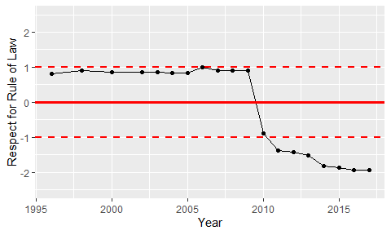

Trend of the Respect for the Rule of Law